The accuracy and convergence of spectral models for the sea surface and rogue waves simulation
Kristina V. Litvenko*, Sergei M. Prigarin¹

The sea surface roughness is sufficiently well described by a random Gaussian field, which is stationary with respect to time and homogeneous with respect to space. Spectral models of the sea surface were used to solve series of applied problems by Monte Carlo method, including the simulation and research into the rogue or freak waves. We use conditional spectral models of random fields for the numerical simulation of rogue waves [1, 2, 3]. A realization of a conditional spectral model of the sea surface with a rogue wave is presented in Figure 1.
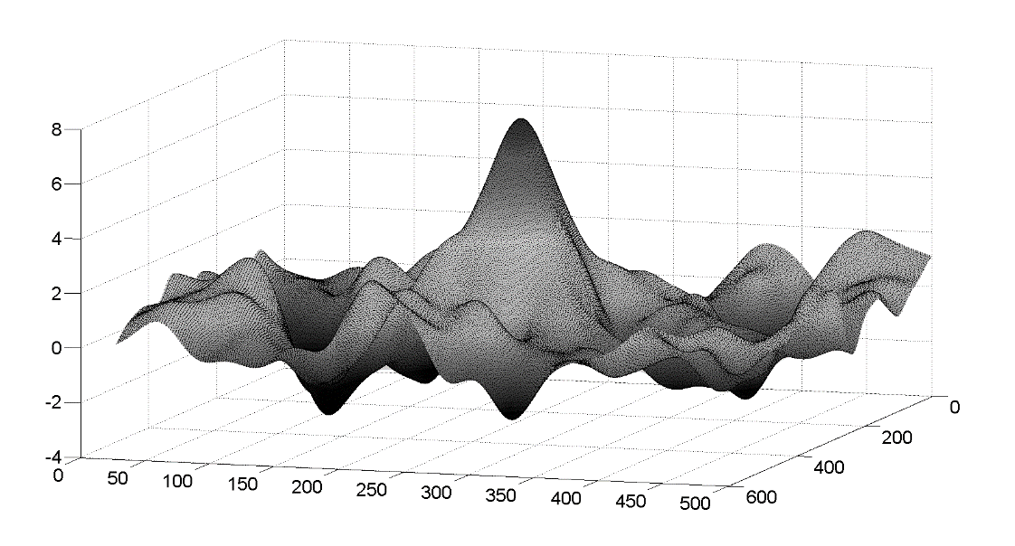Figure 1: An example of the simulated topography of the rogue wave (a realization of conditional spectral model). The values on the axes are given in meters.

In this paper, we study sufficient conditions for the convergence in various function spaces of the sea surface undulation models based on the spectral decomposition of the stochastic field of the water level. We analyze numerical errors for the functionals of spectral models of the sea surface roughness in order to estimate the accuracy of the stochastic models.
This research was supported by the Russian Foundation for Basic Research (Project 18-31-00159).

References

[1] Prigarin S.M., Litvenko K.V., Conditional spectral models of extreme ocean waves. Russian Journal of Numerical Analysis and Mathematical Modelling (2012), V.27, No.3, P.289-302

[2] Litvenko K.V., Prigarin S.M., Numerical stochastic models of sea surface undulation and extreme ocean waves. Numerical Analysis and Applications (2014), V.7, No.4, P. 293-303.

[3] Litvenko K.V., Prigarin S.M., The error analysis for spectral models of the sea surface undulation. Russian Journal of Numerical Analysis and Mathematical Modelling (2014), V.29, No.4, P. 239-250.

* Corresponding author: litchristina@gmail.com Institute of Computational Mathematics and Mathematical Geophysics, Siberian Branch of Russian Academy of Sciences, Novosibirsk, Russia.
Novosibirsk State University, Novosibirsk, Russia.

